The Twin Roman Catholic Parishes of
St. Agnes & St. Anthony
ELEVENTH SUNDAY IN ORDINARY TIME
YEAR B – June 16, 2024
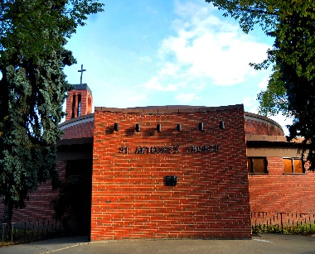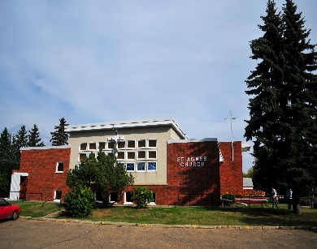
St. Anthony St. Agnes
10661-82 Avenue 10826-62 Avenue

Edmonton, AB T6E 2A6 Edmonton, AB T6H 1N1
Ph: 780- 432-0611 Ph: 780- 432-0611
Fax: 1-825-514-9046

Office Hours: Monday – Friday
9:00 am – 12 Noon and 1:00 pm – 4:00 pm

E-Mail: stanthony.edm@caedm.ca
Parish website: twinparishes.caedm.ca

St. Agnes & St. Anthony Joint Mission Statement
As sharers in the mission of Jesus Christ, we are committed to spreading the Gospel and building up the kingdom of God in our homes, in our parishes, and in the communities in which we live.
***************************************************************
St. Agnes & St. Anthony Parish Staff:
Pastor Rev. Varghese Munduvelil CFIC
Deacon Guy Germain
Deacon Michael Pucylo
Deacon Ramon Morales
Business Manager Don Wong
Administrative Assistant Florentina Suce
******************************************
Twin Parishes Financial Pulse
Full Year
June 8 & 9 Actual YTD Budget
Sunday, Holy Day $4,675 $173,201 $432,000
Building Maint. Fund $270 $43,129 $65,000
Together We Serve $30 $9,363 $30,000
*******************************
CONFESSION SCHEDULES
Every Wednesday @ St. Anthony 5:00 - 5:45 PM
Every Saturday @ St. Agnes 4:00 – 4:50 PM
First Friday @ St. Agnes 6:00 – 6:50 PM
No confession on Saturday evening @ St. Anthony & Sunday due to the mass scheduled continuously.
Call the parish @ 780-432-0611 for a confession appointment. Approach the priest before and after mass during weekdays.

Twin Parishes Masses for the Week
Tuesday, June 18  Mass @ St. Anthony | 7:00 pm
Wednesday, June 19  Adoration @ St. Anthony  Mass @ St. Anthony | 5 - 6 pm  6: 15 pm
Thursday, June 20  Mass @ St. Agnes | 9:00 am
Friday, June 21  Mass @ St. Agnes | 9:00 am
Saturday, June 22  Mass @ St. Agnes  Mass @ St. Anthony | 5:00 pm  7:30 pm
Sunday, June 23  Mass @ St. Agnes  Mass @ St. Anthony  Mass @ St. Agnes | 9:00 am  10:30 am  12 Noon
DONATION OPTIONS:
St. Agnes and St. Anthony would prefer if you used the Pre-Authorized Giving method to have their church donations set up for automatic withdrawal from their banks. Please email or call the parish office @ 780-432-0611 or register, if you wish to adopt this method.

Other Options are:
E-Transfer You may E-Transfer your church donation to StAnthonyEdm.etransfer@caedm.ca. Your donation will be automatically deposited to the account of The Twin Roman Catholic Parishes of St. Agnes & St. Anthony at RBC Royal Bank.
Envelope, place your envelope in the donation basket at Mass or mail your envelope to:
St. Anthony,
10661-82 Avenue NW Edmonton,
AB T6E 2A6
Online Donation, click on “My Offering” from the electronic version of the website, and follow online steps.
Thank you for being a good steward of St. Agnes/St. Anthony Parish with your support and generosity. Every gifts is truly appreciated.
******************************************
Registering for FORMED is easier than ever:
- Go to formed.org/signup; click the 3rd button: I belong to a parish organization.
- Select your parish: Enter Postal Code T6E 2A6 and select St. Anthony from the dropdown menu.
- Register with your name and email address
- Check that email account for a link to begin using FORMED.

Children’s Liturgy at St. Agnes will take a pause for the summer but will start again in September at the 9:00 am Mass.
SACRAMENTS

FIRST RECONCILIATION AND FIRST HOLY COMMUNION

Please call the parish office 780-432-0611 for more information and registration for 2024-2025.

CONFIRMATION PREPARATION CLASS –If your children are between the ages of 11 to 14, please call the parish office for more information and registration for 2024-2025.

RCIA (Adapted for Children age 7 -14)
RCIA (Rite of Christian Initiation for Adults – age 15 and above) Call the parish office for more information and registration for 2024-2025.

MARRIAGE: Because the church is deeply concerned about each marriage, couples are asked to give a minimum of six months notice prior to the intended date of their wedding. Normally the parish boundaries determine in which parish marriage planning should take place.

FUNERAL: Family or designated person by the family should contact the Parish Office for funeral arrangements with the parish priest.

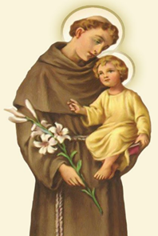
Procession & Potluck!
Sunday, June 16th!
10:30 AM Mass
St. Anthony Church
10661 – 82 Avenue

ST. ANTHONY PANTRY FOR THE NEEDY
To honour our patron, the parish is collecting gifts cards for the St. Anthony pantry to give to the unhoused neighbours and to the needy. Over the next month, we invite parishioners to donate gift cards in the small denominations of $10 to $15. We welcome the gift cards for Safeway, Dollar Store, Tim Hortons, Superstore and McDonalds. It is enough for those in need to buy their next meal. Whyte Avenue and our neighborhoods have many people surviving on the street. You can drop the gift cards in the Sunday collection basket. However, we cannot offer a charitable receipt for such donations. Next Sunday, will re-start the children’s bottle collection during Sunday masses: young children are invited to contribute change to the jar set by the altar. Thank you for continuing St. Anthony of Padua’s care for the poor.
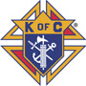
Knights of Columbus Corner
Holy Trinity Council No. 12353

UPCOMING EVENTS

1) “COR” is Christ Centered brotherhood. Our Second “COR” meeting will be held on Sunday, June 23, 2024, after the 10:30am mass in St. Anthony’s Padua Room. The format is a short talk followed by round-table participant sharing. Come join your brother parishioners for coffee and find out why COR is life-changing.

2) St. Anthony's grounds crew is looking for volunteers to help with the maintenance of the flower beds around the church property. We need a few parishioners to help us prepare the soil, remove weeds and move and add plants. We will meet on the first and third Monday of the month at 7:00PM. Contact Allan Opperthauser at 780-222-4687 for more information.
******************************************
Tree Righteousness: Scott Hahn Reflects on the 11th Sunday in Ordinary time
In the cryptic message of the prophet Ezekiel, long centuries before the Lord’s coming, God gave His people reason to hope. Ezekiel glimpsed a day when the Lord God would place a tree on a mountain in Israel, a tree that would “put forth branches and bear fruit.” Who could have predicted that the tree would be a cross on the hill of Calvary, and that the fruit would be salvation?
Ezekiel foresees salvation coming to “birds of every kind”—thus, not just to the people of Israel, but also to the Gentiles, who will “take wing” through their new life in Christ. God indeed will “lift high the lowly tree,” as He solemnly promises.
Such salvation surpasses humanity’s most ambitious dreams. And so we express our gratitude in the Psalm: “Lord, it is good to give thanks to you.” It is indeed good, and better still to give thanks with praise. The Psalmist speaks of those who are just upon the earth, but looks to God as the source and measure of justice, of righteousness. Like Ezekiel, he evokes the image of a flourishing tree to describe the lives of the just. The image, again, suggests the Cross as the measure of righteousness.
The Cross is a sign of contradiction to those who would rather “flourish” in worldly terms. As St. Paul emphasizes to the Corinthians, we need courage. Our faith makes us strong, and it is proved in our deeds. He reminds us that we will be judged by the ways our faith manifests itself in works: “so that each may receive recompense, according to what he did in the body, whether good or evil.”
God Himself will empower the works He expects from us, though we freely choose to correspond to His grace. In the prophetic oracles, He scattered the seed that sprang up and became the mustard tree, large enough to accommodate all the birds of the sky, just as Ezekiel had seen. He gave this doctrine to His disciples in terms they were able to understand, and He provided a full explanation. In the sacraments He provides still more: the grace of faith and the courage we need to live in the world as children of God.

