The Twin Roman Catholic Parishes of
St. Agnes & St. Anthony
First Sunday of Advent Year A
November 27, 2022
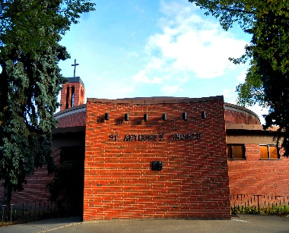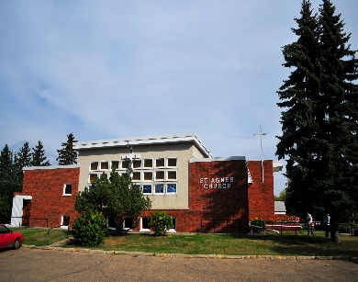

St. Anthony St. Agnes
10661-82 Avenue 10826-62 Avenue
Edmonton, AB T6E 2A6 Edmonton, AB T6H 1N1
Ph: 780- 432-0611 Ph: 780- 432-0611
Fax: 780-434-4969

Office Hours: Monday – Friday
9:00 am – 12 Noon and 1:00 pm – 4:00 pm

E-Mail: stanthony.edm@caedm.ca
Parish website: twinparishes.caedm.ca

St. Agnes & St. Anthony Joint Mission Statement
As sharers in the mission of Jesus Christ, we are committed to spreading the Gospel and building up the kingdom of God in our homes, in our parishes, and in the communities in which we live.
***************************************************************
St. Agnes & St. Anthony Parish Staff:
Pastor Rev. Varghese Munduvelil CFIC
Deacon Guy Germain
Deacon Michael Pucylo
Deacon Ramon Morales
Business Manager Don Wong
Administrative Assistant Florentina Suce
Custodian Bruce Huynh
******************************************
Twin Parishes Financial Pulse
Full Year
Nov. 19 & 20 Actual YTD Budget
Sunday, Holy Day $ 11,460 $305,465 $332,000
Building Maint. Fund $ 775 $26,815 $30,000
Together We Serve $ 210 $24,531 $30,000

“Bring the whole tithe into the storehouse, that there may be food in my house. Test me in this,” says the LORD Almighty, “and see if I will not throw open the floodgates of heaven and pour out so much blessing that there will not be room enough to store it.” Malachi 3:10

May God bless you in your response to His love
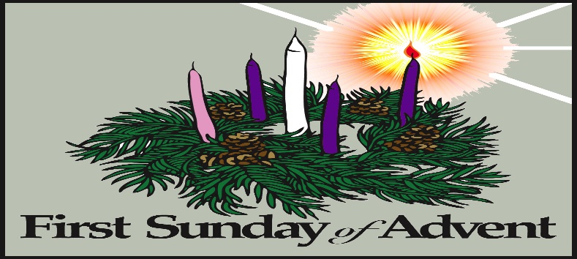

But when the right time came, God sent his Son, born of a woman, subject to the law. God sent him to buy freedom for us who were slaves to the law, so that he could adopt us as his very own children. And because we are his children, God has sent the Spirit of his Son into our hearts, prompting us to call out, “Abba, Father.” Now you are no longer a slave but God’s own child. And since you are his child, God has made you his heir. Galatians 4:4-8
******************************************
Twin Parishes Masses for the Week
Tuesday, November 29  Mass @ St. Anthony | 7:00 pm
Wednesday, November 30  Adoration @ St. Anthony  Mass @ St. Anthony | 5:00 pm  6:15 pm
Thursday, December 01  Mass @ St. Agnes | 9:00 am
First Friday, December 02  Mass @ St. Agnes | 7:00 pm
Saturday, December 03  Mass @ St. Agnes  Mass @ St. Anthony | 5:00 pm  7:30 pm
Sunday, December 04  Mass @ St. Agnes  Mass @ St. Anthony  Mass @ St. Agnes | 9:00 am  10:30 am  12 Noon
To all the parishioners who are interested in having their church donations by automatic withdrawal from their banks please email or call the parish office @ 780-432-0611 to register.

DONATE BUTTON
Parish website: twinparishes.caedm.ca

Here are three ways to give:
St. Agnes and St. Anthony would prefer if you use:
Pre-Authorized Giving Agreement Form
Envelopes can be dropped off or mailed to the parish office at:
St. Anthony,
10661-82 Avenue NW Edmonton,
AB T6E 2A6
Donate online: 

Thank you for being a good steward of

St. Agnes/St. Anthony Parish.

Every gift is truly appreciated.
ANNOUNCEMENT

- If you need a 2023 parish donation envelope please email or contact the parish office to order.
- Knights of Columbus Pancake Breakfast will be on Sunday, December 4, 2022 at St. Agnes Hall. Cost $7/ per person & $20 for family of four.
- Advent Penitential Service Tuesday, Dec. 13th at 6:00 PM St. Agnes Church.
******************************************
CHURCH DONATION E-TRANSFER
You can E-Transfer your church donation to StAnthonyEdm.etransfer@caedm.ca will be automatically deposited to the account of The Twin Roman Catholic Parishes of St. Agnes & St. Anthony at RBC Royal Bank. Thank you for your support and generosity.
**************************************

JOIN US IN ADORATION

Adoration on Wednesday,  November 30 5:00 pm – 6:00 pm | St. Anthony Church
SACRAMENTS
For First Reconciliation/Communion, Confirmation,
RCIA (Rite of Christian Initiation for Adults, Marriage, Funeral and Anointing of the Sick. Please contact the parish office for more information.
******************************************
RCIA SESSIONS
The RCIA team wishes to open up their sessions to all parishioners of St. Agnes/ St. Anthony who wish to learn about the Catholic Faith. The RCIA sessions are held on Wednesday evenings at 7:00 p.m. - 9:00 p.m. in the Padua room of St. Anthony church. The topic for the next session is: The One, Holy, Catholic and Apostolic Church Wednesday, November 30, 2022.
******************************************
CALLED TO PROTECT TRAINING
There will be a “Called to Protect” training session on Tuesday, November 29, 2022 starting at 7:00 pm to 9:30 pm.
The two and half session is mandatory for all volunteers and employees of the Archdiocese. This is a virtual session by zoom. Please register using the link below:
Registration: https://forms.gle/x3NRXzgEM8AmAABA7

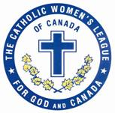
CWL CORNER
“Learn more about the Catholic Women’s League at www.cwl.ca or www.edmontoncwl.org”

ST. AGNES CWL
St Agnes CWL is hosting a cash fundraising Christmas bake sale on Sunday, Dec. 4 in St. Agnes hall following the 9 am and noon masses. Consider donating baked goods or a monetary donation in lieu of baking. Suggested items should be bake sale ready: pies, cakes, cookies, squares, muffins, scones, cupcakes, and loaves. Please label if gluten and/or nut free. Donations will be accepted in the Connelly Room starting Saturday, Dec. 3 at 4:30 pm and before the Sunday masses.

CWL is holding a Holy Hour on Thursday, December 8, 2022, after the 9 a.m. mass at St. Agnes. All parishioners of our twin parish are welcome.
******************************************

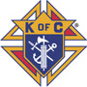
Knights of Columbus Corner
Holy Trinity Council No. 12353
Monthly Theme: Family

RAFFLE: Alberta Knights of Columbus 50/50
- Visit: https://www.rafflebox.ca/raffle/kocab/123
- Sales Ends Friday, December 9th 2022
NEXT BINGO: Friday, December 9, 2022 @ Parkway Bingo
- 8775-51 Avenue NW
- AFTERNOON SHIFT FROM 10:30 AM TO 5:00 PM
- Brother Knights, Wives, Daughters, Sons, Family Members and Parishioners over 18 years of age are encouraged to volunteer and to help at a bingo.
PLEASE let us know if you can help:
CONTACT: Dennis Stansfield, Bingo Coordinator
Cell Phone: 780-910-4626 (Leave a message)
E-Mail: denstansfiled@shaw.ca
THANK YOU FOR HELPING!
**********************************************
Registering for FORMED is easier than ever:
1. Go to formed.org/signup; click the 3rd button: I belong to a parish organization.
2. Select your parish: Enter Postal Code T6E 2A6 and select St. Anthony from the dropdown menu.
3. Register with your name and email address
4. Check that email account for a link to begin using FORMED.

